The recommendations for preparing illustrations for The journal "National Health Care (Russia)"»

In the program you use to view CT, MRI, and other images, always look for the maximum possible output size.

Four steps to download images with the maximum power level and size from RadiAnt DICOM:
4 шагa для скачивания изображений с максимальным разрешением и размером из RadiAnt DICOM:

STEP 1.
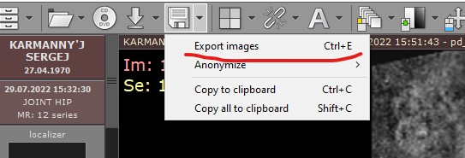

STEP 2.
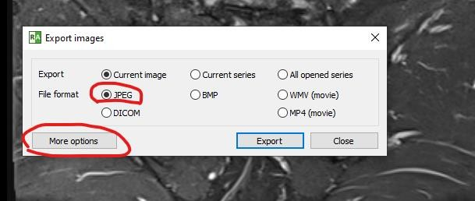

STEP 3.

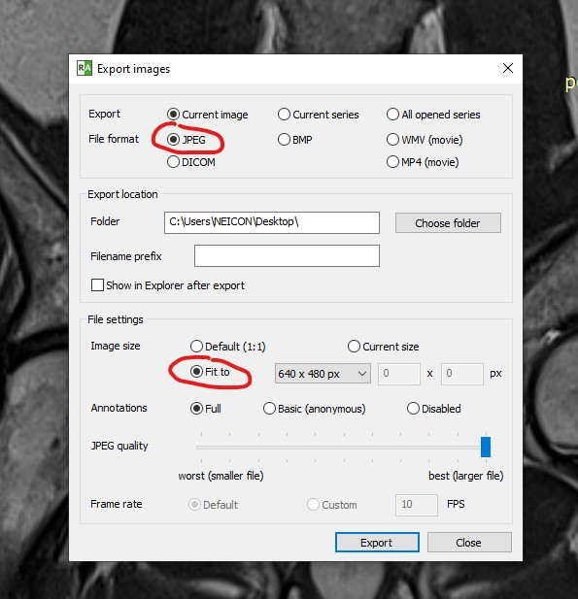

STEP 4.
